THE CYCLONIC BUYER JOURNEY™
FRAMEWORK PLAYBOOK
Persona And Messaging Development

THE CYCLONIC BUYER JOURNEY
The modern buyer journey is dizzying. Overwhelmed by information, prospects can enter any stage at any time, bounce back and forth between stages and get stuck or, even worse, lost in their own journey. The Cyclonic Buyer Journey depicts this chaotic experience through eight interconnected cycles that reflect the complexity of the decision-making process.
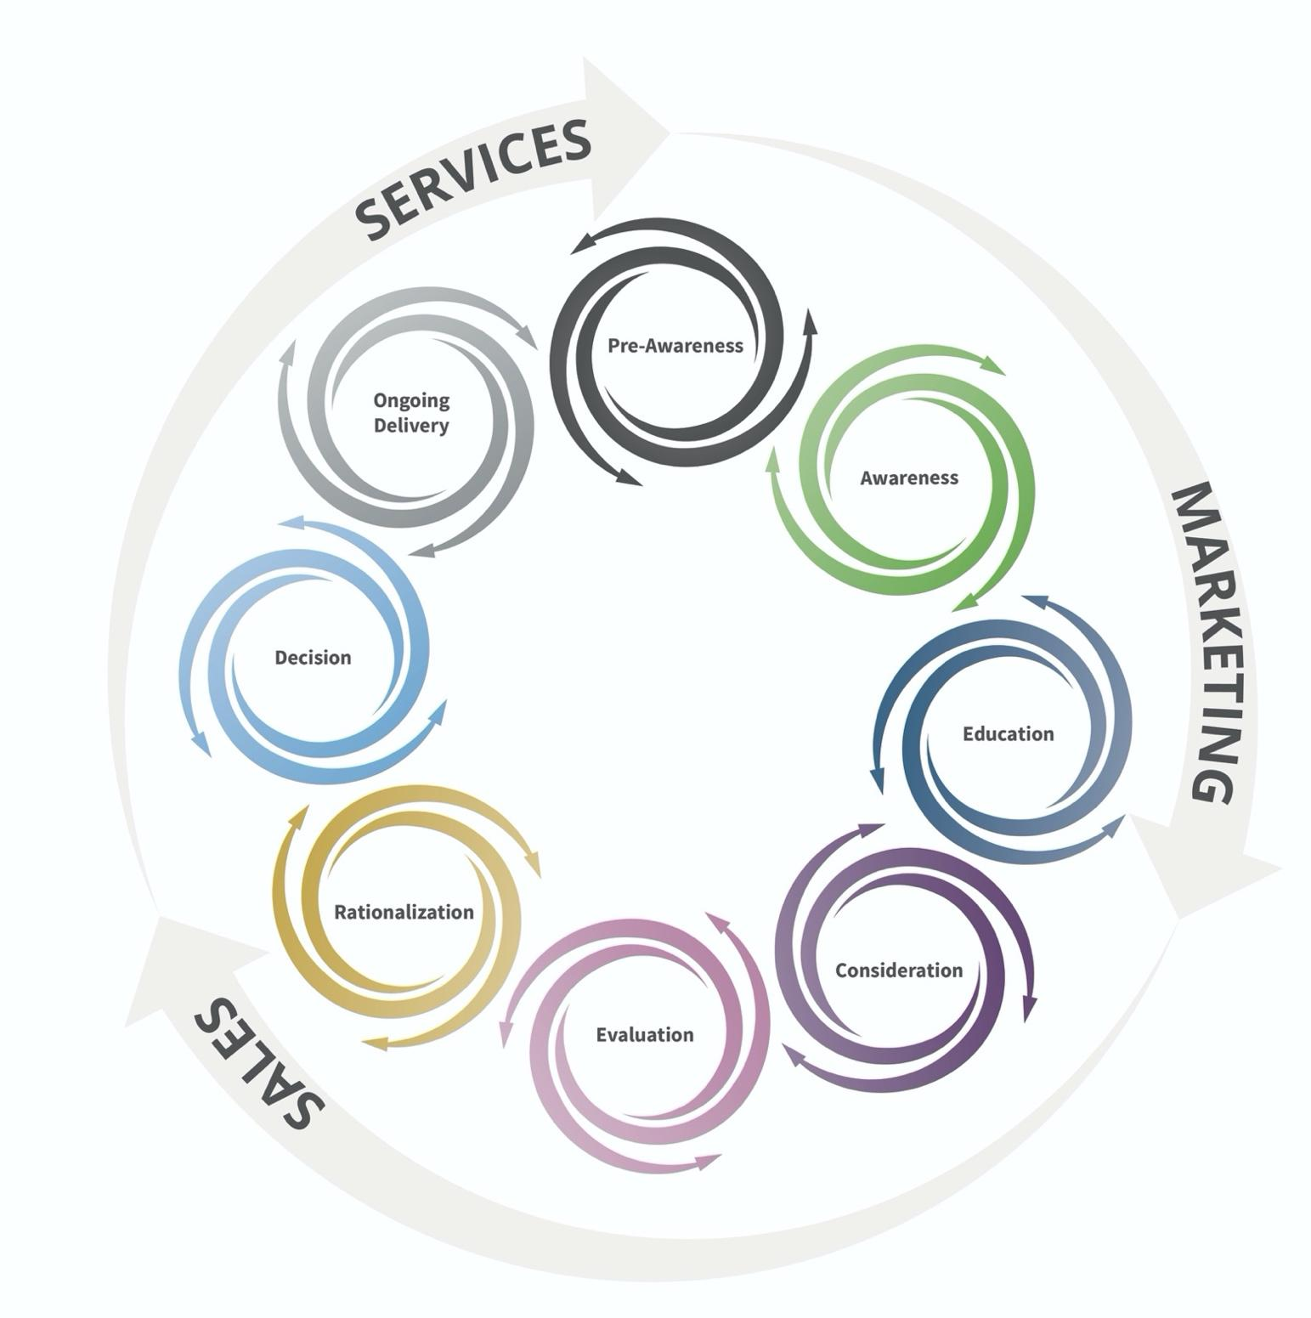
PERSONA DEVELOPMENT
Fill in the following information for your primary persona. The goal is to bring the persona to life in a way that allows you to understand their wants and needs, so be as detailed and specific as possible. Repeat the exercise for each target persona.

DEMOGRAPHICS
Title(s)
Age range
Male/female split
Number of years in the industry
Role in the buying process
(e.g., decision- maker, influencer, user)
Geographic area(s)
Place in the buyer journey
(e.g., Pre-Awareness, Consideration)
BACKGROUND AND IDENTIFIERS
Professional background
(e.g., worked his/her way up from an analyst role)
Attributes and traits (e.g., influenced by peers, prefers short content, excited by new technology, afraid of change, etc.)
Sources of information
(e.g., magazines, websites, associations, LinkedIn, etc.)

PERSONA DEVELOPMENT
GOALS
What is their primary goal? (e.g., keep data center running with zero downtime)
What is their secondary goal? (e.g., reduce budget)
PAINS AND SOLUTIONS
Pain 1: | e.g., “We need a quick and cost-effective way to migrate to the cloud.”
Solution 1:
Pain 2:
Solution 2:
Pain 3:
Solution 3:
Pain 4:
Solution 4:

PERSONA BUYER JOURNEY QUESTIONS
Fill in the questions your target persona asks in each phase of the buyer journey to uncover the answers you’ll need to provide to create a seamless buying experience. Be as specific as possible, using the provided examples as a guide. Repeat the exercise for each target persona.

PRE-AWARENESS  (I don’t yet know that I have a problem.) | AWARENESS  (I recognize I have a problem that needs my attention.)
Am I doing everything I should be doing to deliver on my job responsibilities? | How are other companies in my industry handling this issue?
What are other people in my industry doing | How are other people in my role handling this issue?
What are other people in my role doing? | What are some first steps that I should consider IF I want to take action?
How is my company performing when compared to others in my industry? | What are some of the potential outcomes if we don’t take action?
Are there any issues that I should be thinking about? | What might a full solution require if we decide this is an issue we need to address?

EDUCATION  (I am actively gathering information about possible solutions.) | CONSIDERATION  (I am narrowing down my options.)
What types of solutions are available? | Should we hire someone in-house to handle this?
What do solutions typically cost? | Should we buy software to improve this situation and mitigate this challenge?
What types of companies provide solutions that seem to match what I think I need? | Should we use an outside company to consult with us on this issue?
What have other companies purchased? | What have other companies done?
How have other companies solved this challenge? | How long would each of the different scenarios take to resolve this?
How can I be sure this is something we actually need? | How much does each scenario cost?
I want to know all my options around mitigating this; who has information?

EVALUATION  (I am weighing pricing, capabilities and key benefits of a few finalists.) | RATIONALIZATION  (I am asking tough questions to justify my decision.)
How does your solution compare to other similar solutions? | Who exactly will be on our team if we implement your solutions?
How long will it take to realize our business outcomes from your solution? | When exactly do you think we could kick off your program?
How much does your solution cost? | Who can we speak with regarding their experience?
Why would your solution work better for us and our specific requirements? | Do you have references we can talk with?
What makes your solution special? | What were some of the business outcomes similar businesses received from your solution? Success stories?

DECISION  (I am reviewing the contract details and legal obligations of the deal.) | ONGOING DELIVERY  (I am evaluating the relationship and considering other purchases.)
What does the paperwork, contract and/or agreement look like? | How are we doing?
Can we make changes to your paperwork? | Would you refer us to a friend, peer or colleague?
How will we pay for the solution? Are there terms? | Would you be willing to write an online review?
What are the remedies if we're not happy? | Would you be willing to do a video testimonial?
Can we negotiate price, terms and/or scope? | Would you be an active advocate and participate in ongoing marketing and sales activities if asked?

MESSAGING
To create messaging, start by pulling forward the pains uncovered during persona development. Then identify the differentiators that allow you to solve for those pains in a unique way.

PERSONA PAINS TO TARGET
Pain uncovered during persona development

DIFFERENTIATORS
Solutions/services/processes that separate you from the competition

The Anatomy of Effective Messaging
Combine persona pains and differentiators to create clear and concise messaging that:
- Is persona-focused
- Speaks to your persona’s problems and how you solve them
- Separates you from the competition
- Is emotional, memorable and compelling
- Makes prospects want to learn more

Effective messaging often takes the form of a bold, attention-grabbing headline paired with an explanatory subhead, such as:

Tomorrow Is Just A Dream Away
Experience new enchantment and classic favorites at Walt Disney World Resort

Messaging Scratch Sheet
Messaging development is a process of generating lots of ideas, many of which aren’t very good. Still, jot everything down – bad ideas often inspire better ideas.

HEADLINES | SUBHEADS

Square 2 is a full-service revenue growth agency designed to produce results for clients. We help businesses understand the changing buyer journey and how revenue is directly related to marketing, sales and customer service execution.

We help our clients with strategy, tactics, analytics and technology to build revenue generation machines that produce month-over-month revenue growth in a scalable, predictable and repeatable way.

We use our Cyclonic Buyer Journey™ model to help clients map their prospects’ buyer journeys to the right sales, marketing and customer service tactics. We use our AI-powered recommendation engine software called MAXG to drive a more scientific set of recommendations for our clients.

We’re so sure of our approach that we guarantee results for clients every 90 days. To learn more, visit www.square2marketing.com.

